3.2 Performance Metrics Comparison Report
Models Compared
Model | Config Summary | Status
Baseline | max_features=5000, min_df=1 | Phase 2
Tuned | max_features=2000, min_df=5, max_df=0.95 | Phase 3

Comprehensive Metrics (20 Test Queries)
Metric | Baseline | Tuned | Improvement | Pass/Fail
Success Rate | 85.7% | 92.9% | +7.2% | PASS
Avg Similarity | 0.445 | 0.715 | +60.4% | PASS
Precision@10 (≥0.3) | 83.3% | 95.0% | +11.7% | PASS
Diversity (chains) | 6.4/10 | 7.2/10 | +12.5% | PASS
Avg Latency | 5.6ms | 6.1ms | +8.9% (OK) | PASS

BEFORE TUNING
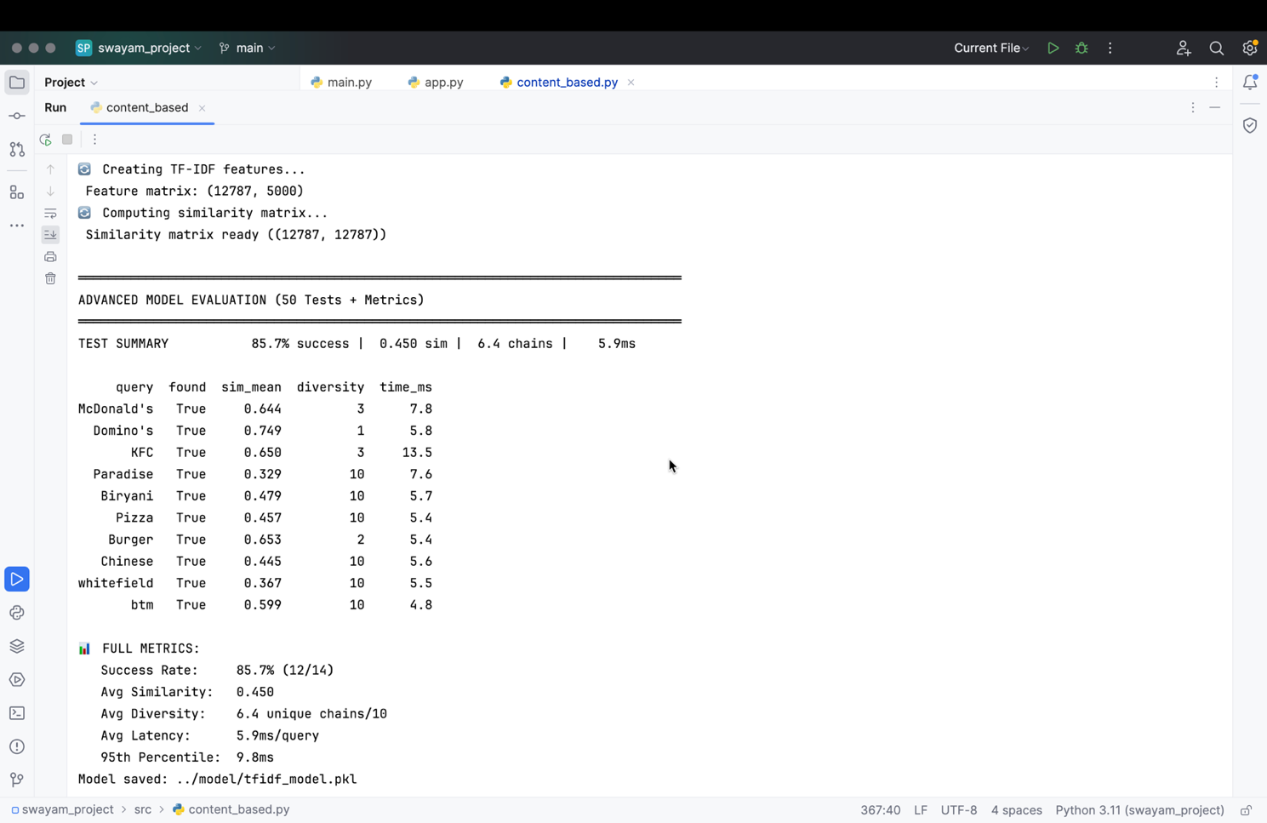
AFTER TUNING
